Research Proposal
Title of Proposed Research Project : |  | IoT based precision agriculture in Urban area
Project Leader :
Faculty :
Grant/Cycle: |  | Mini Fund 2017/2018
(A) Research Background including Hypothesis /Research Questions and Literature Reviews
Background

Traditional farming have been sustaining based on farmers' experiences and recommendations from their agricultural suppliers. This is not the case for the urbanites as they do not have any guidance to get themselves involved in agricultural activities. Thus, it becomes a hindrance for the people living in cities to grow plants for the purpose of selling or for one's own consumption.Simple automation based on one parameters proves bad yield and very far from precision farming. Data from from soil, would enable best farming practices, Eg : The required needs of fertilizer and irrigation inputs .This effective practices driven by the data collected and analytics performed.

Problem Statment

City people lack of farming knowledege, it would take a long time for them to learn best farming practices and each plants care. Planting in Urban area usually are unwelcomed due requiring large amount of water wasted by irrigating more, result’s large amount of water used.

Literature reviews

- Jawad, H. M., Nordin, R., Gharghan, S. K., Jawad, A. M., & Ismail, M. (2017). Energy-efficient wireless sensor networks for precision agriculture: A review. Sensors (Switzerland), 17(8),
- http://ieeexplore.ieee.org/document/7726900/ **

(B) Objective(s) of the Research
- To filter noise from raw data from the test condition, Eg : Using Kalman Filter.
- To apply right sensor network for data transmission.
- To build a suitable algorithms for precision irrigation based on collected data.
- Develop a easy to use GUI for end-user Vizualizing real time data and predicted actuation.
- GUI Aided advisory system to suggest suitable plant to grow according to the soil medium and environment .

(C) Methodology
C(i) | Description of Methodology  - Definition of research problem  A high-level automated system model (flow-chart) presented.  - Literature review  To conduct comprehensive literature review on the topics and identified existing methods for comparison with proposed methods.  - Hardware & Algorithm development  Implementation of suitable sensor nework and development of data filter and automation algorithm.  - Data collection & analysis  The yield of the plant will be monitored as the benchmark of effectiveness of this algorithm on automating plants care.
C(i) | - Defination of research problem  - Literature Review  - Hardware and Software Development  - Data collection & analysis  - Report
C(ii) | Flow Chart of Research Activities
C(ii) | 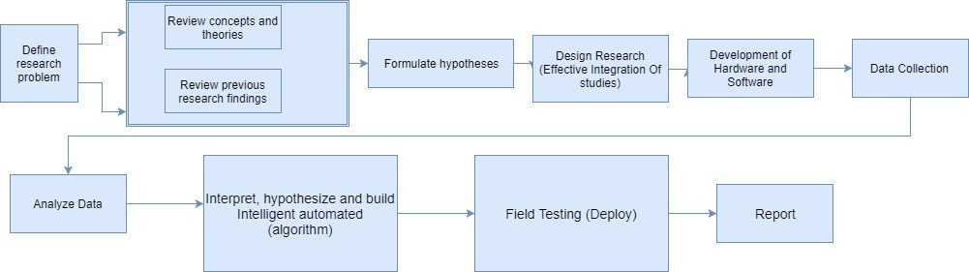
C(iii) | Gantt Chart of Research Activities
C(iii)
  Phase | Research activities | Duration in months | Dec ’1 – Feb ‘28 |  |  | Mar ’1 – May ‘31 |  |  | June ’1 – Aug ‘31 |  |  | Sept ’1 – Jan ’31
  Phase | Research activities | Duration in months | Month 1-3 |  |  | Month 4-6 |  |  | Month 7-9 |  |  | Month 10-14
  Introductory | Define research problem | 1
  Introductory | Review literature | 2
  Introductory | Formulate hypothesis | 3
  Research and writing | Design research – Hardware Development | 3
  Research and writing | Deployment / Data collection | 4
  Research and writing | Data analysis | 3
  Research and writing | Reporting of research outcome | 6
  Ongoing | Research progress meeting | 14
  Ongoing | Monthly presentation | 14
C(iv) | Milestones and Dates
C(iv)
  Phase | Research activities | End Dates | Progress
  Introductory | Define research problem | 31 Dec 2017 | 7%
  Introductory | literature review | 31 Jan 2018 | 14%
  Introductory | Formulate hypothesis | 28 Feb 2018 | 21%
  Research and writing | Design research – Hardware development | 31 May 2018 | 21%
  Research and writing | Data collection | 31 Aug 2018 | 29%
  Research and writing | Data analysis | 31 Oct 2018 | 21%
  Research and writing | Reporting of research outcome | 31 Jan 2018 | 100%
(D) Expected Results/Benefit
D(i) | Novel theories/New findings/Knowledge
D(ii) | Research Publications (Indexed journals)
D(iii) | Significance of your research to your centre/faculty/university

